Remote Control

Pls note that the below describes Remote Access setup between student & teacher PCs.
Video communication between teacher & student is also made simultaneously using either WhatsApp or Teams.

The student will take control of the teacher’s computer via the internet.

They can then work mutually eg on an Excel spreadsheet. This is not one-way learning!

For the teacher:

Start FixMe.IT

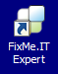
(Expert means Host means Teacher!)

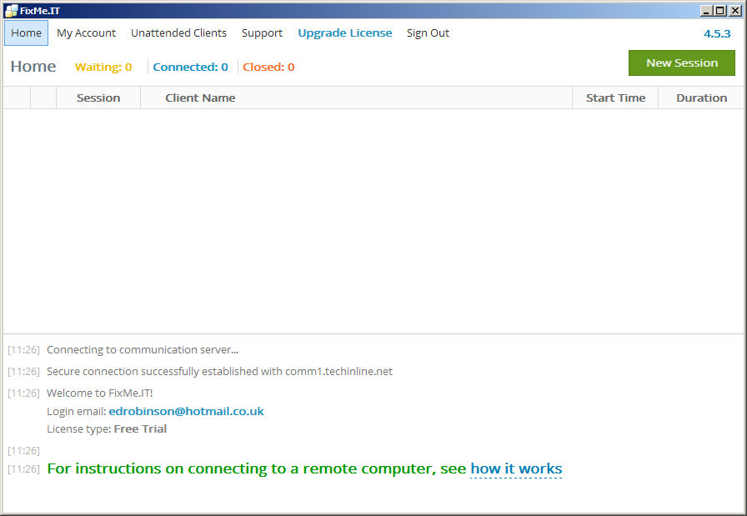
Click New Session.

The teacher is known as the host.

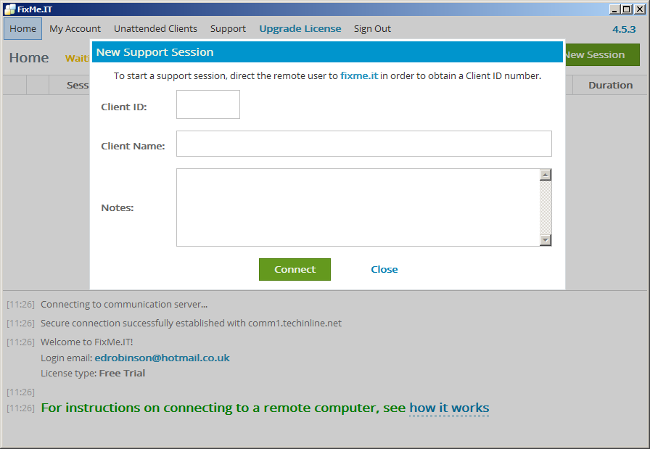

The teacher needs this from the student. See next page.

Teacher types anything he likes for Client Name eg Student1.

For the Student:

Go to this link (ie click on it below).

https://fixme.it/ - or type it in (Don’t Google it! Type it as a URL)
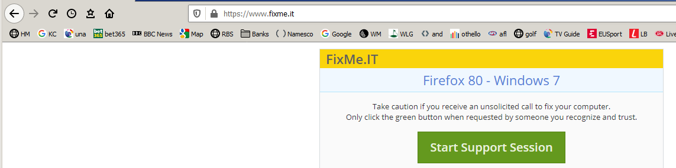
Click Start Support Session.

This dialog box appears:

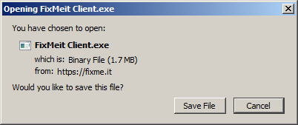
Click Save File.
(Pls note that if you save this exe file to the desktop (or make a short cut) then next time you could simply run it from there!)
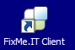

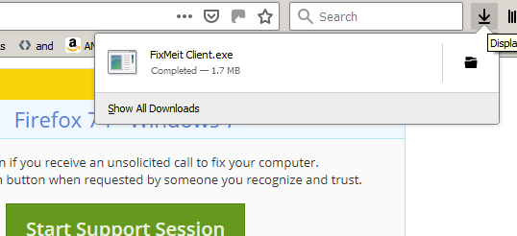
Take a look at the Downloads folder. This is for Firefox browser. If you (the student) are using Chrome then this download folder may be in a different position ie bottom left of the screen.
One way or another we need to run the above .exe file (FixMe.IT.exe)
Click on it to run it.

This appears for the student:
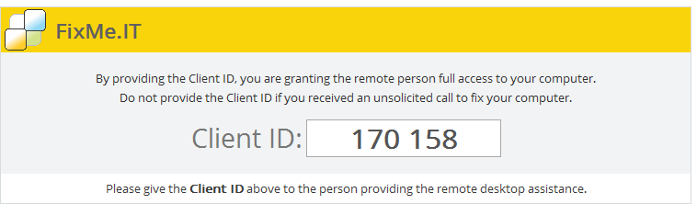

From a security point of view, it is generally not usually a good idea to run such executable programs on your computer. (But in my opinion it is trusted. Ed.) (If you are at work they may disallow it.)

Pass this number on to the teacher by phone or email (or WhatsApp or Zoom).

Back to the teacher:

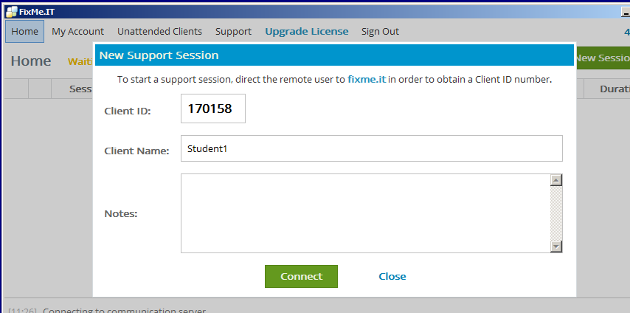

Now the teacher can enter the student’s ID.
(As well as an (optional) Client Name.)

The teacher clicks Connect.

This appears for the teacher.

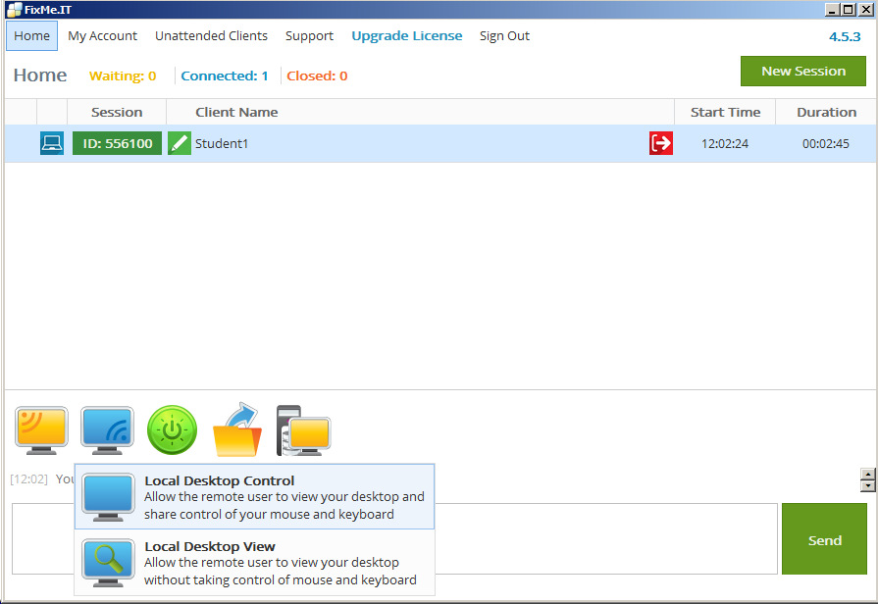
The teacher clicks “Share your desktop with the remote user” then “Local Desktop Control” (to allow the student mouse & keyboard control of the teacher’s computer!)

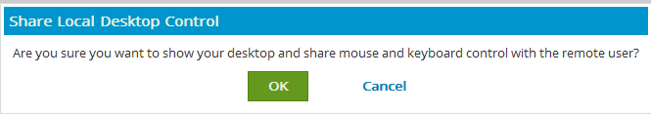
The teacher will click OK.

The Student

will now have control of the teacher,s computer with their keyboard & mouse.

The teacher will also have the same control!

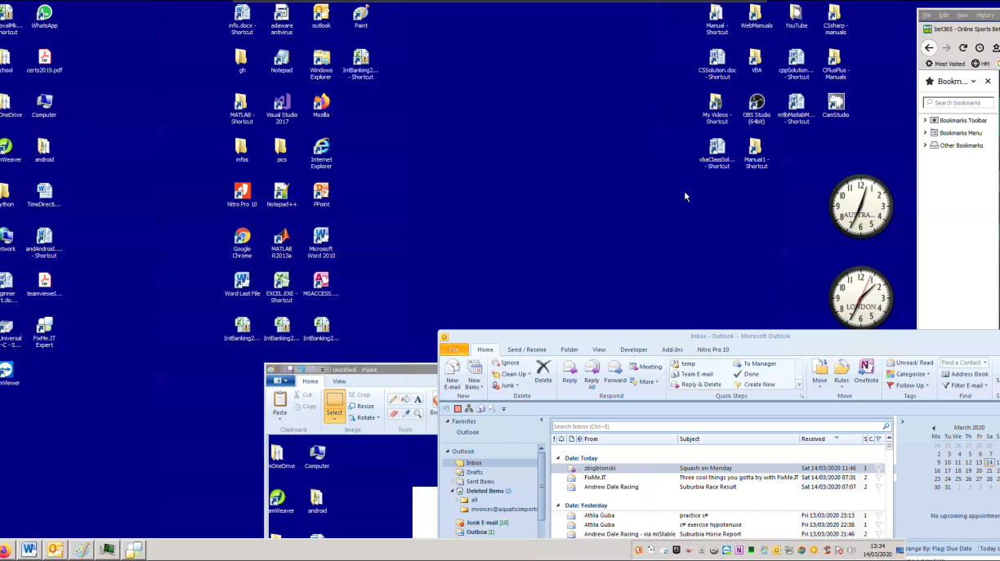

The teacher (or the student!) could now for example open Excel on the teacher’s computer.

They could now both work (& learn) on it together.

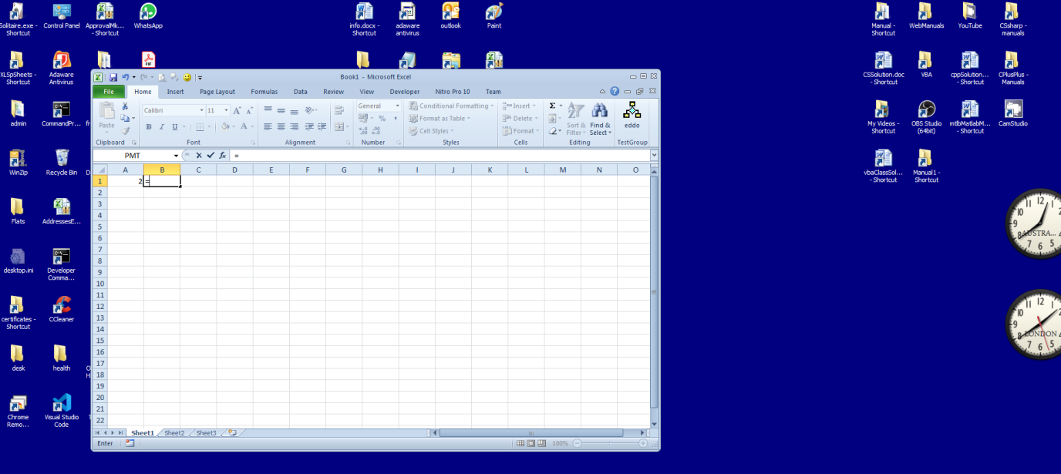

It is a good idea to have WhatsApp video or Zoom or Teams running as well for communicating.

Happy Remote Learning.

Further note for the teacher (not the student!)

To get FixMe.IT up and running in the first place:

Go to the web site https://www.techinline.com/

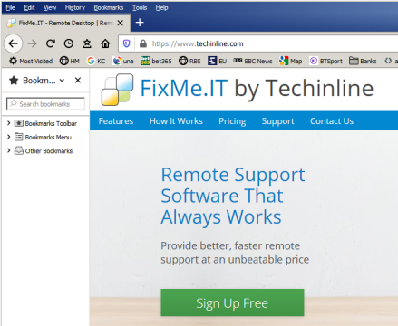

Sign up.
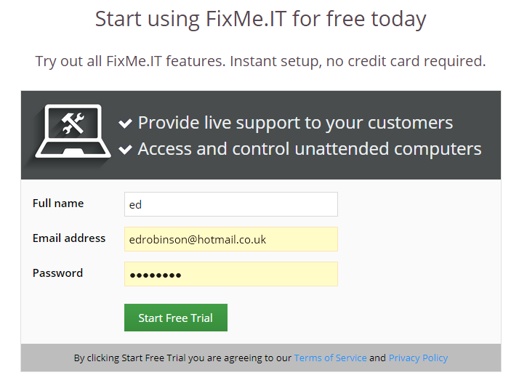

Start Free trial

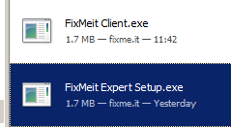
….and run the Expert.exe not the Client.exe.

.

etc

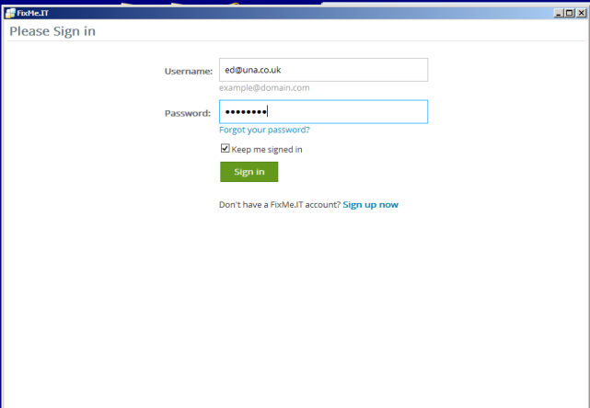

For the Teacher

For Two Clients (Students)
Simply click New Session etc to add another client!!

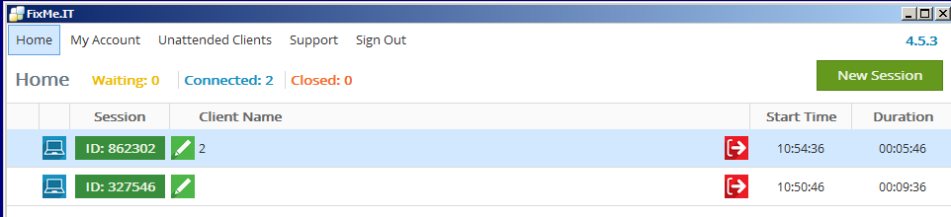
The two students will have the same view (and control!) of the teacher’s computer!!

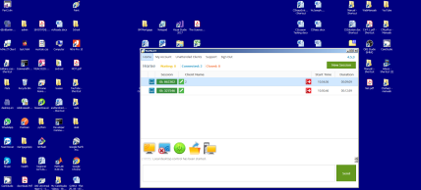
Student1 Student2 Teacher

For 2 experts? https://www.youtube.com/watch?v=J8qicBnuWhI ?

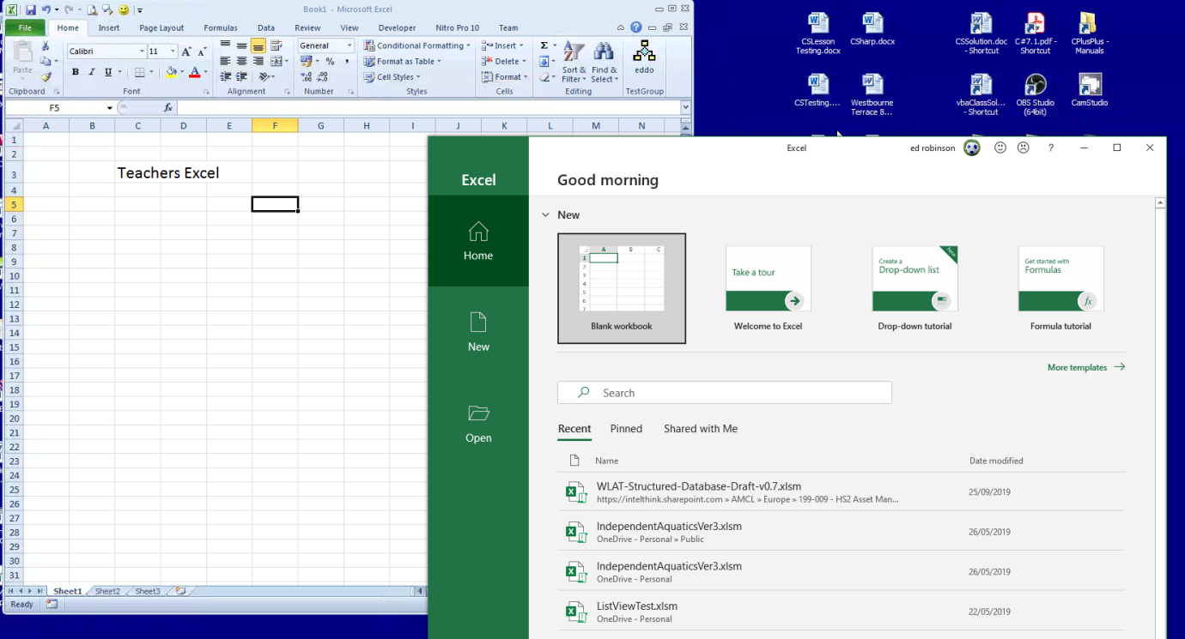
Here is a student’s view of the teacher’s computer:

But - note that the student can open his/her copy of Excel to practise what the teacher demonstrates at the same time!

In order to be the student to be able to open apps like Excel etc simultaneously to the above, he or she should move the mouse to the top of the screen until the FixMeIT bar appears as shown below and then choose the maximise/minimize button – in order for the student to be able to see the Windows task bar at the bottom etc.

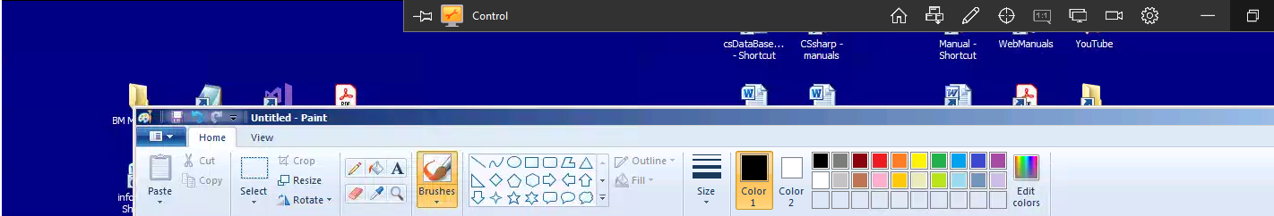


Windows task bar

Even better if the student has a double monitor to be able to watch the teacher’s Excel and his or her own Excel at the same time!

So the student (client) may see something like this: Teacher’s screen on left. Student’s practice area on the right monitor.

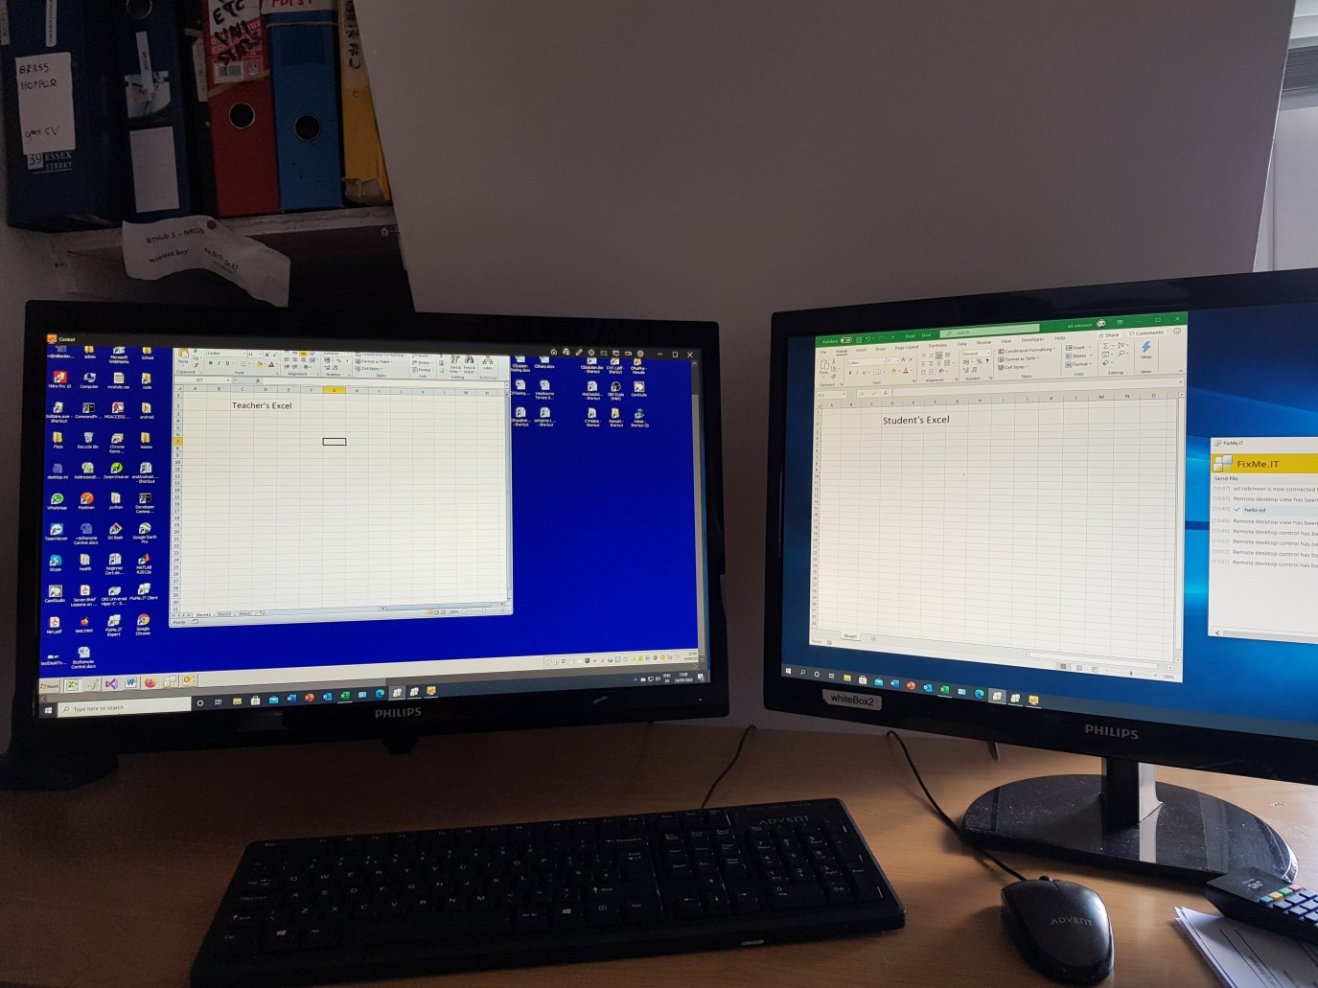

To control the client’s computer (screen & mouse)

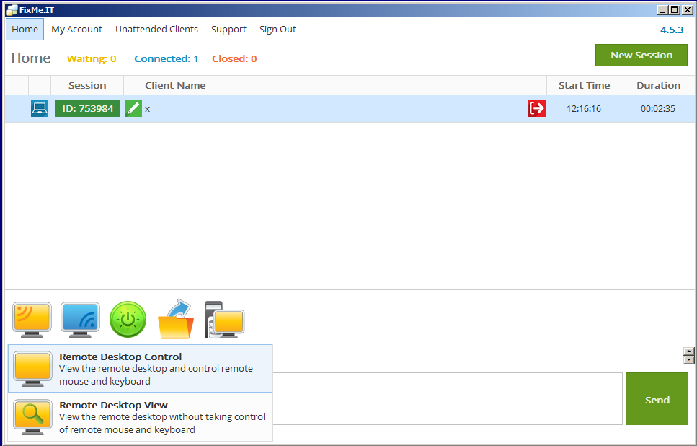

Click this which gives teacher control of one (only) student’s mouse & keyboard.

To Exit

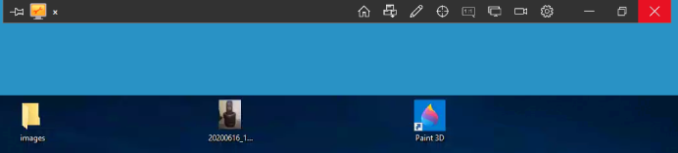

Unattended Access

https://www.techinline.com/How-It-Works

Connect to an unattended remote computer
